PROGRESS REPORT KELOMPOK 3

Bootcamp Management

Selasa, 1 Febuari 2019

Anggota :

Muhamad Ilham Habibie

M. Iqbal Aula Rahman

Proggress :

1. Baru buat 11 mater data kurang 8 master data dan sudah jadi 1 interface untuk coba Login , Menu HR untuk Insert,Update,Delete dan Search table Department dan validasinya.

2. Target besok, selesaiin semua master datanya.

3. Untuk mengerjakan WPF bagian Microservice Data Access sudah jadi Model, Param, Database dan tablenya.

|  |  |  |  |  |  |  |  |
| --- | --- | --- | --- | --- | --- | --- | --- |
| **NAMA** | **MODUL** | **Master Data** | **INSERT** | **READ** | **UPDATE** | **DELETE** | **SEARCH** |
| ilham | achievement |  |  |  |  |  |  |
| batch | v | done | done | done | done | done |
| class |  |  |  |  |  |  |
| dailyscore |  |  |  |  |  |  |
| detaillesson |  |  |  |  |  |  |
| placement | v | done | done | on progress | on progress | on progress |
| room | v | done | done | done | done | done |
| historydetaillesson |  |  |  |  |  |  |
| lesson | v | Done | Done | Done | Done | Done |
| Login | v | Try | Try | Try | Try | Try |
| iqbal | department | v | done | done | done | done | done |
| organization |  |  |  |  |  |  |
| employee | v | done | done | done | done | done |
| errorbank |  |  |  |  |  |  |
| schedule |  |  |  |  |  |  |
| skill | v | done | done | done | done | done |
| skillstudent |  |  |  |  |  |  |
| student |  |  |  |  |  |  |
| taskscore |  |  |  |  |  |  |
| workexperience |  |  |  |  |  |  |
| Login | v | Done | Done | Done | Done | Done |

1. ERD

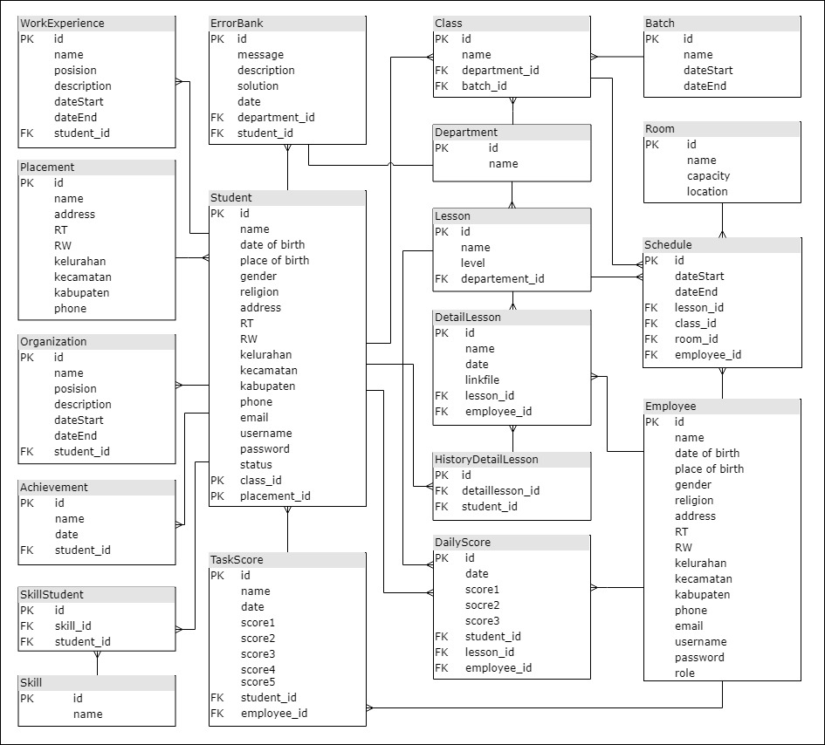

1. Use Case Diagram

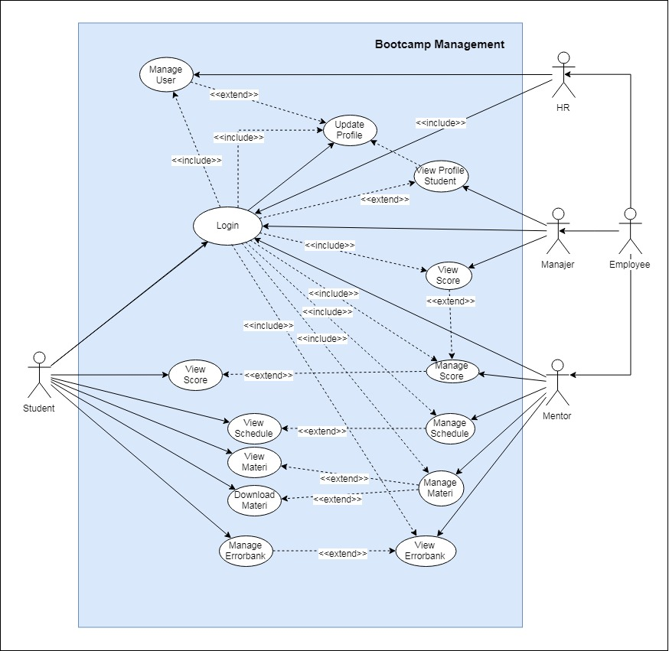

1. Class Diagram

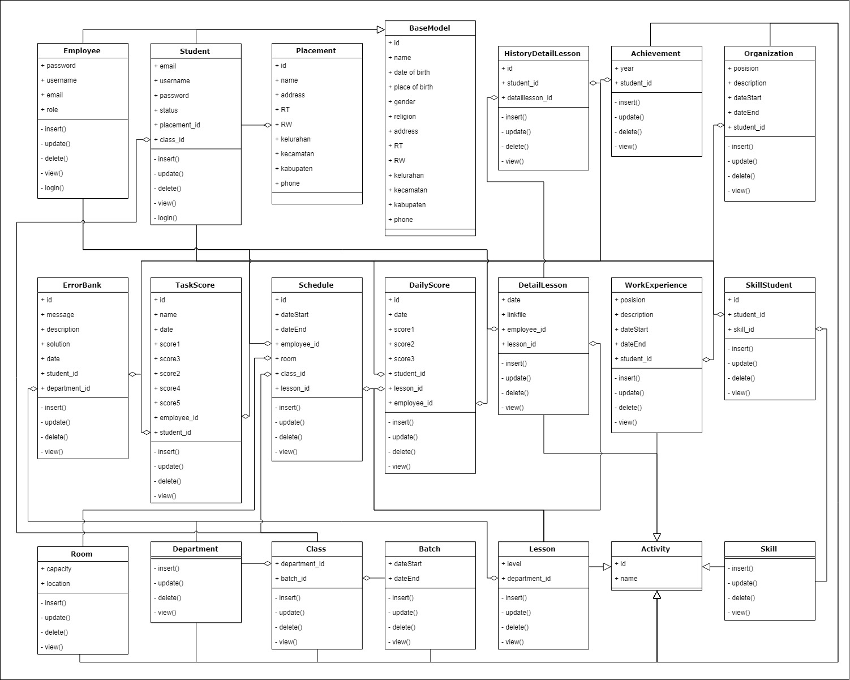

1. Activity Diagram

* HR – Login & HR – Add Manager

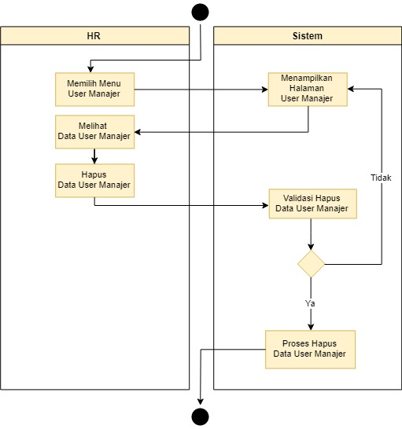 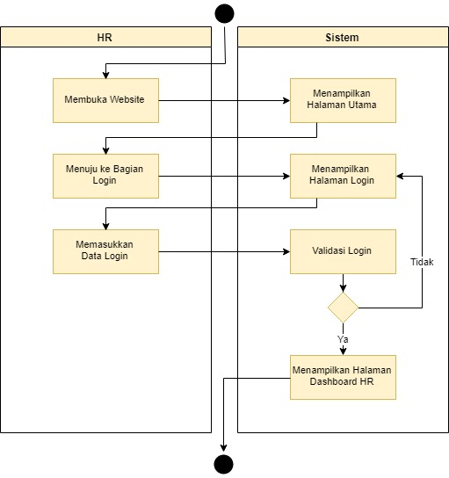

* HR – Update Manager & HR – Delete Manager

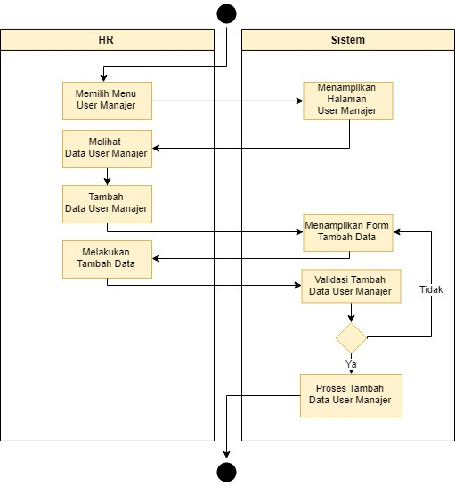 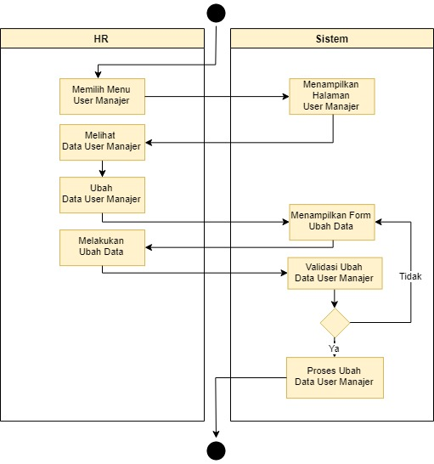

1. WPF Progress

